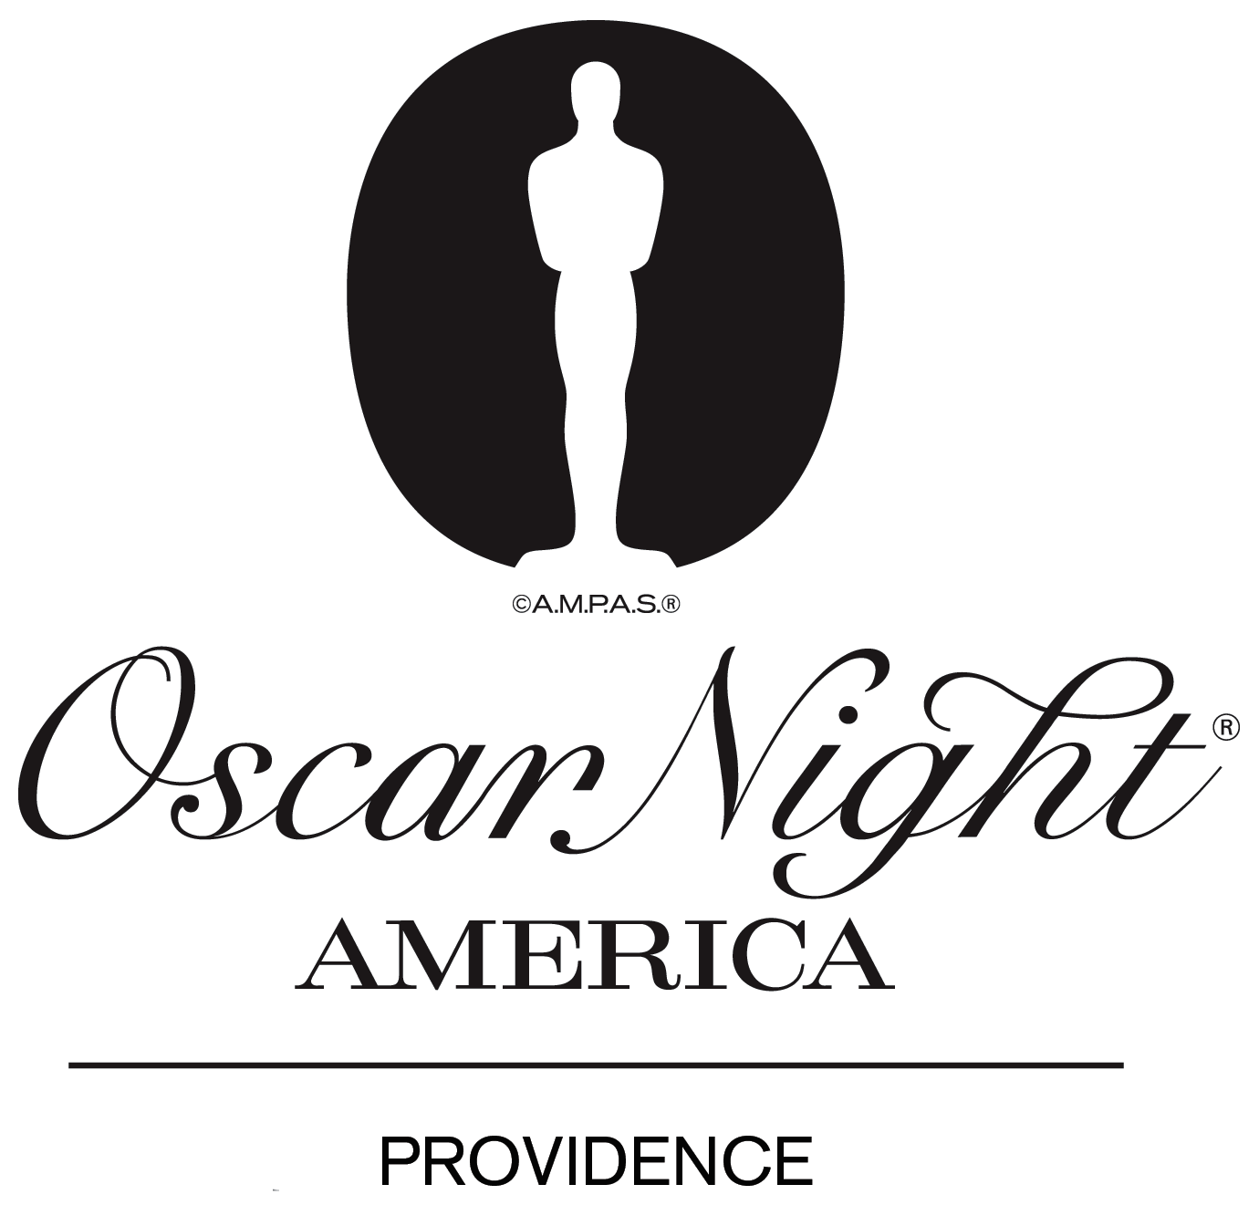

2012 Silent Auction Item Donation Form

To recognize your philanthropic contribution to this year’s Gala event, Flickers: Rhode Island International Film Festival will acknowledge your company or you with the following:

- Name recognition in the Oscar Night® America – Providence 2012 program
- Name or logo recognition on donor sign near auction display (send jpeg file to: jarnold@film-festival.org)
- Name or logo recognition on bid sheet

________________________________________________________________________________________________
Company/Individual Name Date Received
________________________________________________________________________________________________
Company Representative/Individual Title Email
________________________________________________________________________________________________
Address
____________________________________________________________________________________________________City State Zip

YES! The following item(s) is committed to the Oscar Night® America – Providence 2012 Gala:

Quantity | Description | Value

Total Estimated Value of Goods/Services: $_______ Reserve Price (Optional) $_________

Please retain this form for your tax records, as donations are tax deductible. Flickers: RI International Film Festival is a qualified charitable organization under Section 501(c) (3) of the Internal Revenue Code. Our tax ID# 05-0399728. No goods or services were provided by Flickers: RI International Film Festival in exchange for this contribution.

__________________________________________________________________________________________
Signature of Donor

THANK YOU FOR YOUR GENEROUS SUPPORT!

